Test Case: tc002_SPX_Dev5_Crear_Requisicion_Spot_Tipo_Cobro_Project
Step 1 - Enter username and password and click to button Enter: Credentials Entered
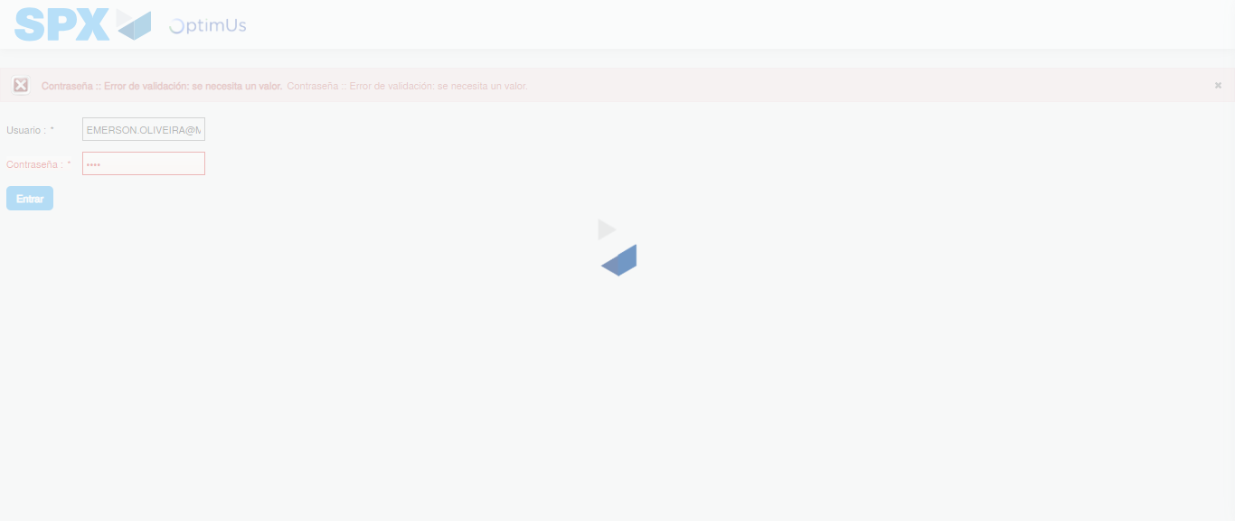Image file-name: QC_Testing-tc002_SPX_Dev5_Crear_Requisicion_Spot_Tipo_Cobro_Project-1784232588148

Step 2 - Select to UEN and Access to Spot Buy Requisitions : UEN Correctly selected and Correct access
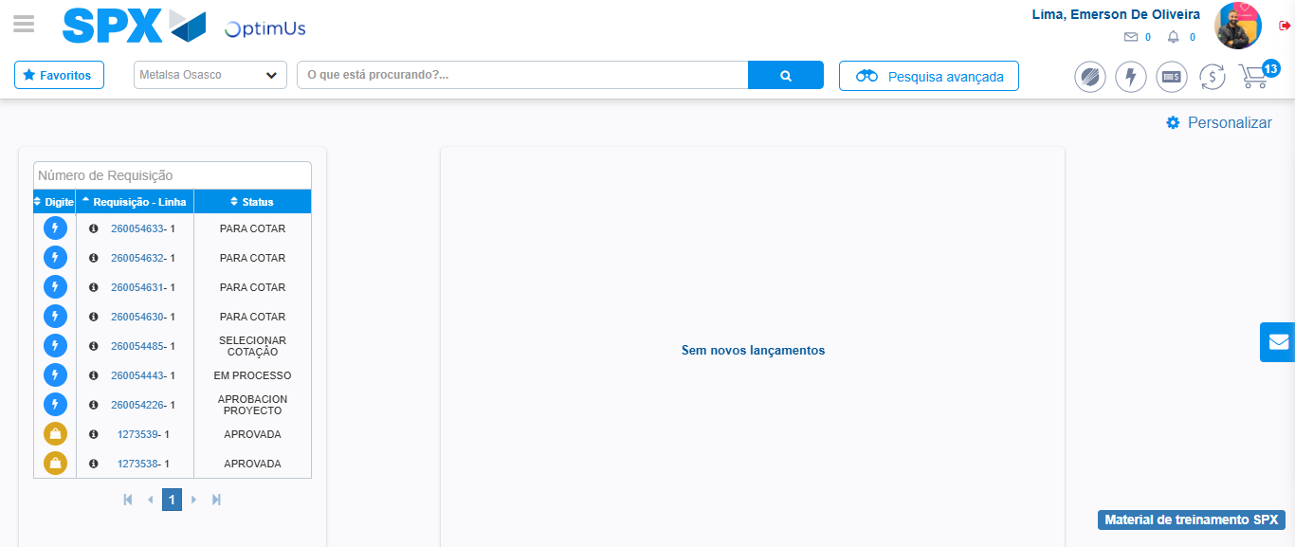Image file-name: QC_Testing-tc002_SPX_Dev5_Crear_Requisicion_Spot_Tipo_Cobro_Project-1784232668301

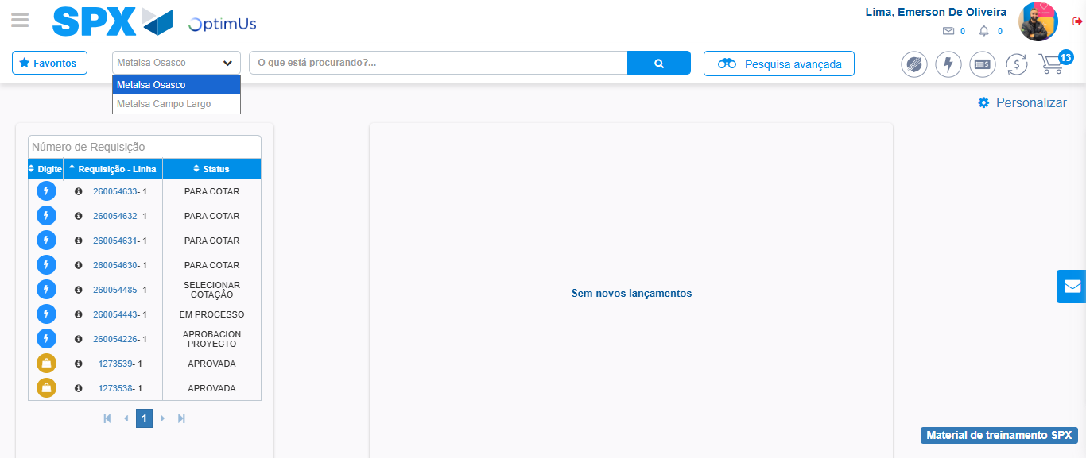Image file-name: QC_Testing-tc002_SPX_Dev5_Crear_Requisicion_Spot_Tipo_Cobro_Project-1784232670793

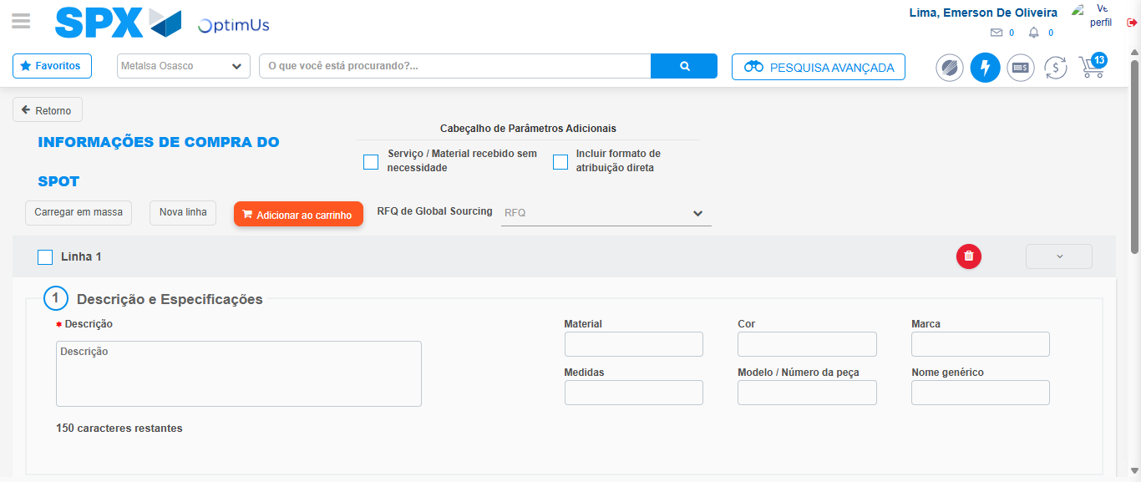Image file-name: QC_Testing-tc002_SPX_Dev5_Crear_Requisicion_Spot_Tipo_Cobro_Project-1784232719512

Step 3 - Data Capture Spot Buy Requisition: Data captured correctly
Image file-name: QC_Testing-tc002_SPX_Dev5_Crear_Requisicion_Spot_Tipo_Cobro_Project-1784232719745

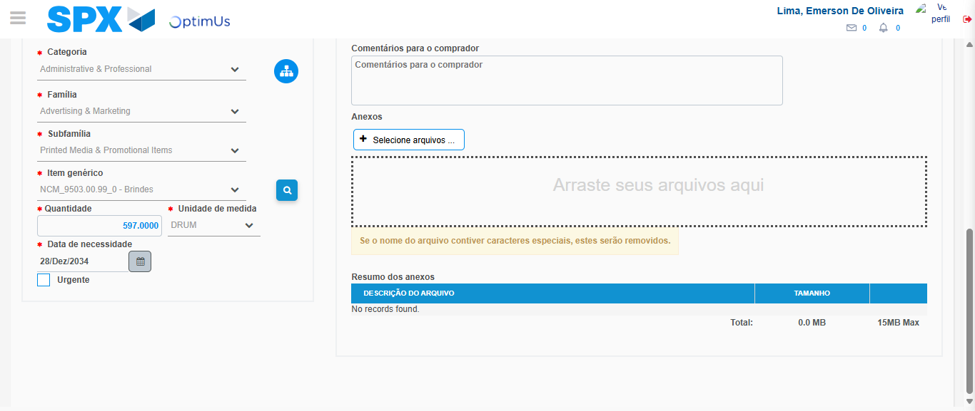Image file-name: QC_Testing-tc002_SPX_Dev5_Crear_Requisicion_Spot_Tipo_Cobro_Project-1784232732071

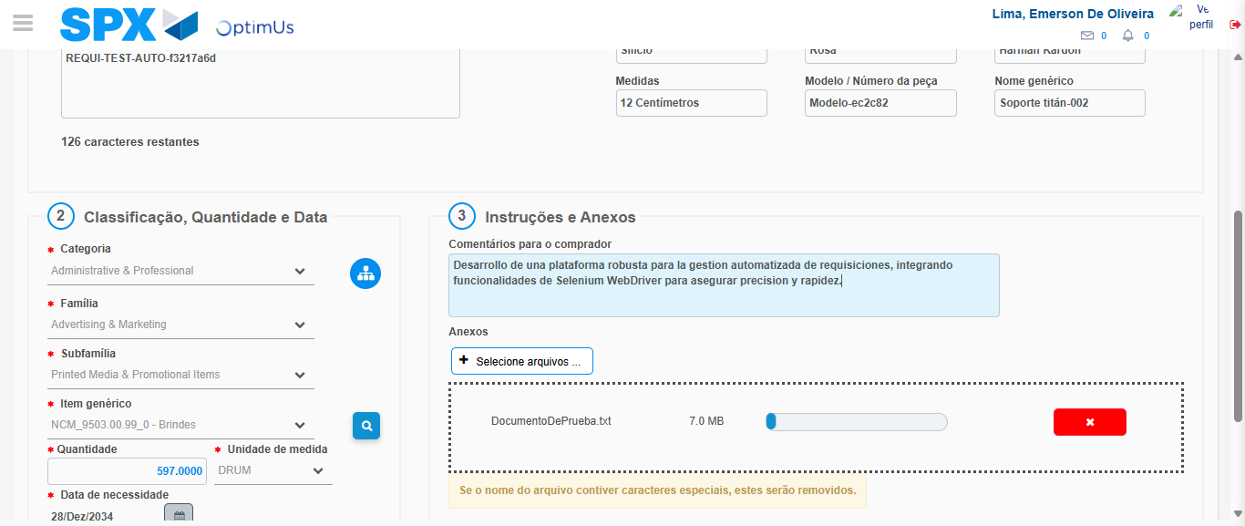Image file-name: QC_Testing-tc002_SPX_Dev5_Crear_Requisicion_Spot_Tipo_Cobro_Project-1784232732826

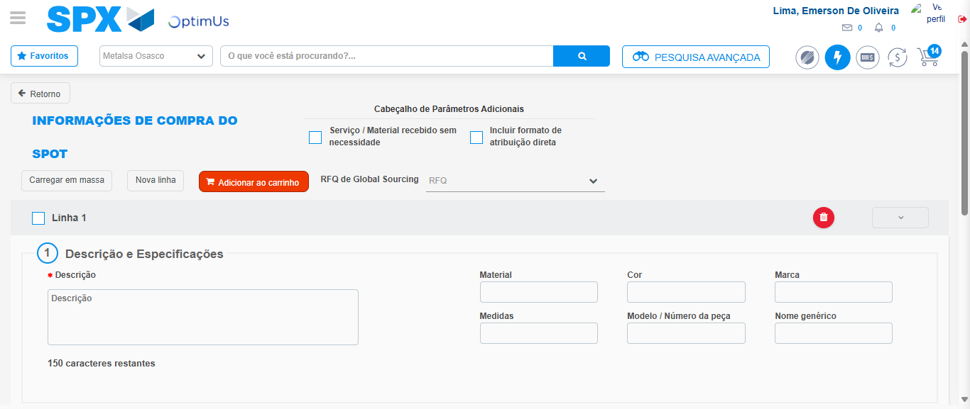Image file-name: QC_Testing-tc002_SPX_Dev5_Crear_Requisicion_Spot_Tipo_Cobro_Project-1784232736651

Step 7 - Return to Main Page SPX : Return to Main Page SPX
Image file-name: QC_Testing-tc002_SPX_Dev5_Crear_Requisicion_Spot_Tipo_Cobro_Project-1784232668301

Image file-name: QC_Testing-tc002_SPX_Dev5_Crear_Requisicion_Spot_Tipo_Cobro_Project-1784232670793

Image file-name: QC_Testing-tc002_SPX_Dev5_Crear_Requisicion_Spot_Tipo_Cobro_Project-1784232719512

Image file-name: QC_Testing-tc002_SPX_Dev5_Crear_Requisicion_Spot_Tipo_Cobro_Project-1784232738924

Image file-name: QC_Testing-tc002_SPX_Dev5_Crear_Requisicion_Spot_Tipo_Cobro_Project-1784232739101

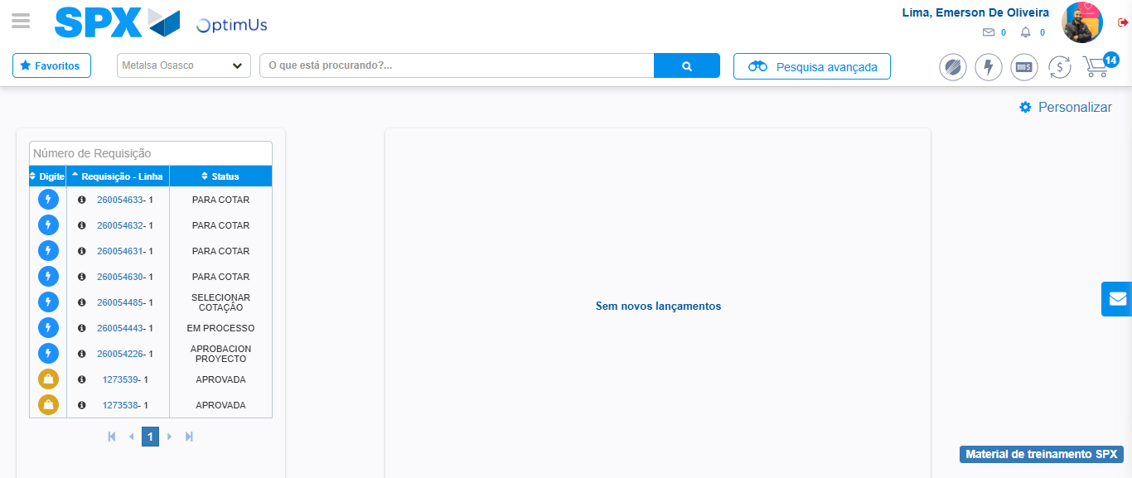Image file-name: QC_Testing-tc002_SPX_Dev5_Crear_Requisicion_Spot_Tipo_Cobro_Project-1784232760100

Step 8 - Log Out : Log Out SPX
Image file-name: QC_Testing-tc002_SPX_Dev5_Crear_Requisicion_Spot_Tipo_Cobro_Project-1784232760279

